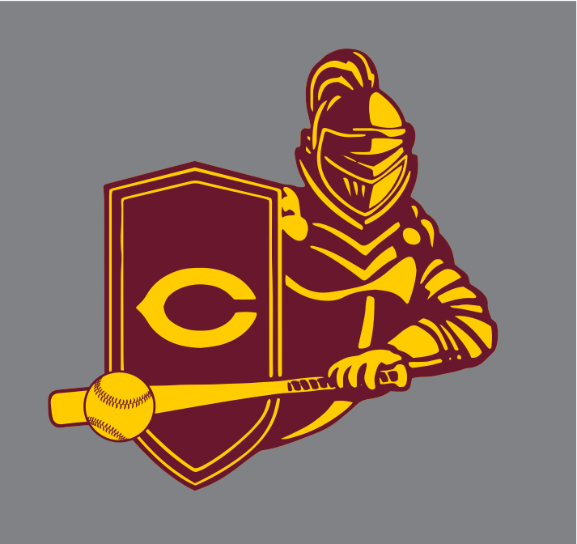
Indicate any lettering on back of any item $5.00 extra
Name Desired:_____________________________ (on which item(s)_________________________
Any number desired on back $4.00 extra
Number#:_______ (on which item) ____________________________________________________
Name:___________________________________________________________ Book#:__________
(For Staff) Room Number:_______________ referred by team member______________
Email:___________________________________________________________________________
Total enclosed $_______________________ Method of Payment ___________________________
Checks payable to Central HS * ALL items include CHS baseball logo
+$1 +$3
 | Prices | YS | YM | YL | AS | AM | ALG | AXL | 2XL | Total
SS T-shirt wh | $10
LS T-shirt | $14
Hoodies- (gray, garnet, maroon)circ | $24
Baseball ¾ sleeve jersey- maroon&wh | $15
Sweatpants gray | $22
Shorts- mesh (mar) | $15
Baseball hat “C” | $15 |  |  | all | mar | oon
New gold C hat | $15
CHS knit cap | $15 |  |  | One | size | shield | log | o | cuff | mar
Cent knit cuff hat | $15 |  |  | one | size | cuff | Cent | ral | two | tone
new beanie ash | $15 |  |  | One | size
CHS Wristband | $1 | circl | c | gold | mar | oon | swirl | half
CHS blanket | $25 |  |  | mar | oon
UnderArmour hoodie | $49 |  |  | shiel | d | logo
ss dri fit | $19
Backpacks | $10 |  |  | draw | string
Crew top( grey, heather red, crimson)-circle | $18
Headband /sweatband | $5 |  |  | gray | with | CHS

Strict deadline to place order is January 24, 2015 in which the order will be placed. Thank you very much for your support of our team.
Please return form with payment to any team member or send to room 64 to Mr. Weiss (adv rm. 50) email rweiss@philasd.org or mail to
Central Varsity Baseball, Attn: R. Weiss
1700 W. Olney Ave., Phila. PA 19141

