CENTRAL HIGH BASEBALL ALUMNI GAME REGISTRATION
Saturday June 9, 2018 – 10:30 AM

Name _______________________________________________ class#_________
Email __________________________________________
Cell # ___________________________________
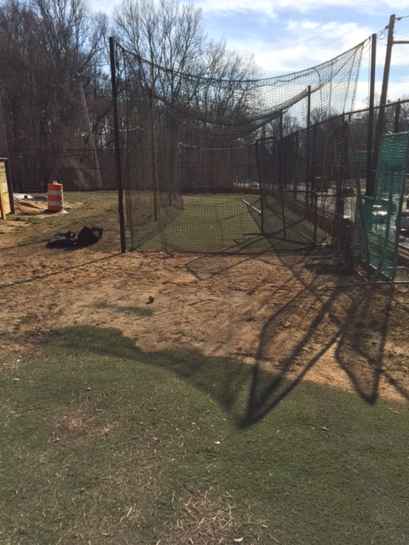
Jersey size _______________________
Name on back _______________________
Our new batting cage!
Number desired on back _____________________

OR if you are getting the event T-shirt, T-shirt size__________

Hat size s-m l-xl 2xl

Positions preferred- _________________ Can you pitch? _________ Catch?_________

Can you provide a wood bat? Y

This game is for a CHS Varsity Baseball Fundraiser to help us to purchase equipment, uniforms, supplies, out of city bus trips, field upgrades and more.

Fee of $100 includes PIAA umpires, UPGRADED personalized jersey, official CHS game hat, hoagies for post-game social on the field, field prep work, field man salary

$________100 registration for custom jersey entry
$________60 registration for T-shirt entry
$_______ additional donation to CHS Baseball (optional/appreciated)
$_______ donation to CHS Senior baseball player scholarship fund (optional)
$ ______ total payment submitted- method of payment _____________

Send checks payable to Central HS (note baseball alumni game lower left bottom) to
Coach Rich Weiss
Central High
1700 W. Olney Ave.
Phila PA 19141
Attn: baseball alumni game

or Paypal to rweiss@philasd.org- by MAY 1

Please submit registration form, liability waiver and payment together by May 4. Thank you- email Coach Weiss , chairmen Bob Barthelmeh (228) bobpbart@gmail.com or Mike Monroe with any questions.

Join our CHS Baseball facebook page:
https://www.facebook.com/Central-High-Baseball-1523209341253531/?fref=ts
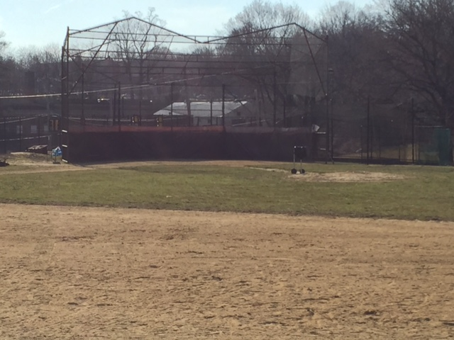

***submit this form and waiver

2018 Annual CHS Baseball Alumni Game (the “Event”)
READ CAREFULLY – THIS CONTAINS A WAIVER AND RELEASE FROM LIABILITY
In consideration for my being permitted to participate in the Event at Central High School (the “Location”):
1. Assumption of Risk. I understand the nature of the Event and I am able to safely participate in the Event. I am fully aware of the risks of unexpected injuries, damage or other loss that may result from my attendance at and participation in the Event. I freely assume all such risks including the risk of any negligence by other participants, The CHS Staff, School District of Philadelphia or any of the organizers or volunteers of the Event or any of the other Released Parties as defined below.
2. Liability Release and Promise Not to Sue. I hereby release from liability, waive any and all claims against, forever discharge and hold harmless The SDP, CHS, the owner(s) and lessor(s) of the Location, . and each of their respective affiliated companies or other organizations, volunteers associated with the Event, the organizers and sponsors of the Event and each of their respective officials, owners, partners, directors, officers, trustees, members, employees, representatives and agents, and the other participants in the Event (collectively, the “Released Parties”) of and from any and all claims for injuries, disability, death, property damage, attorneys’ fees or other loss of any kind or nature that may be sustained in connection with my attendance at or participation in the Event or any activity surrounding the Event even if based on the negligence of any Released Party. I further agree not to sue any of the Released Parties for any such claim.
3. Medical Treatment. In connection with any injury I may sustain or other medical condition I may experience during my participation in or attendance at the Event, I authorize any emergency first aid, medication, medical treatment or surgery deemed necessary by the attending medical/first aid personnel if I am not able to act on my own behalf. I further authorize the attending medical/first aid personnel to execute on my behalf any permission forms, consents or other appropriate documents relating to medical attention for me and to act on my behalf if I am not able or immediately available to do so.
I, intending to be legally bound, have carefully read and voluntarily agree to this Waiver and Release and I understand its full legal effect.
Participant’s Signature:________________________ Address: ________________________________________ Print Name: _________________________________ Date: ___________________________________ Birth Date of Participant: _______________________

